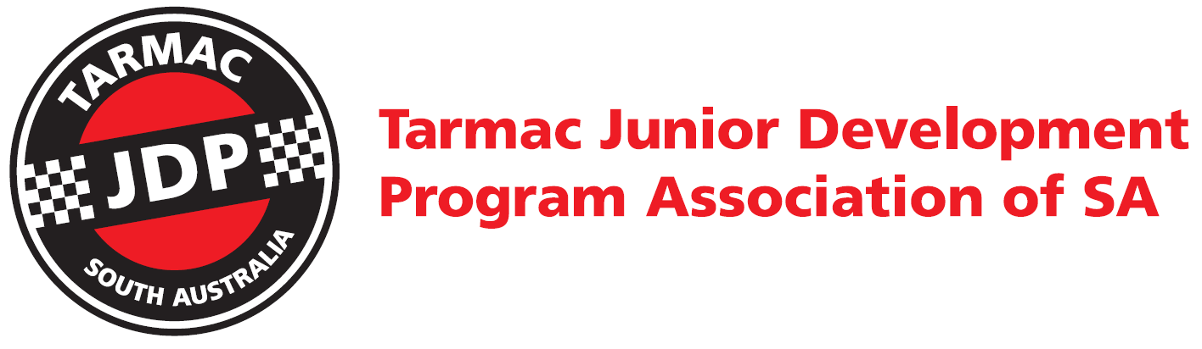

***INTRODUCING JUNIORS TO***

***ENTRY LEVEL MOTOR SPORT***

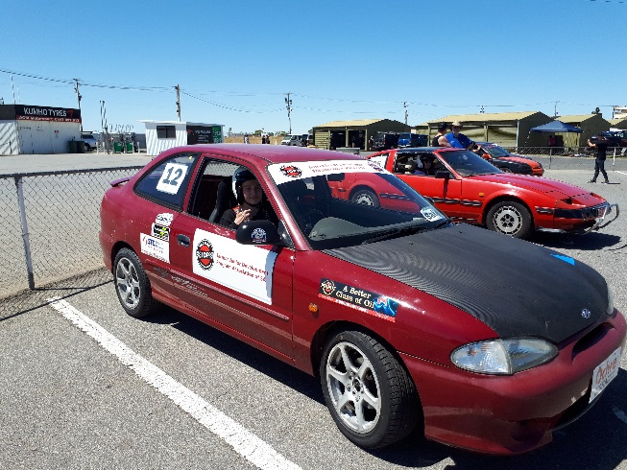 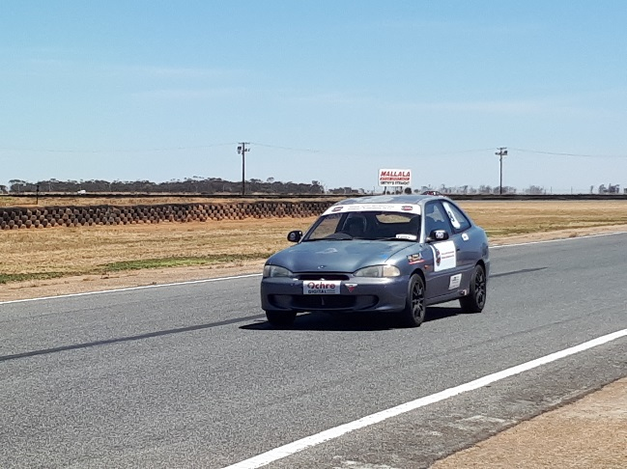



Contents

Tarmac Junior Development Program 3

Introduction 3

Training Activities 4

Theory Training Sessions 4

Special Presentations 5

Driver tuition sessions 5

2020 JDP Program format 5

Day #1 5

Day #2 6

Day #3 6

Day #4 6

BBQ Lunch 6

Registration 6

Clothing 6

Equipment 6

Event Schedules 7

Parents / Guardians 8

JDP Coordinators Contacts 8

Send registration to: 8

Supporters 9

Optional 2020 Tarmac JDP Speed Event Shirt 10

Application Form 2020 12

# Tarmac Junior Development Program

## Introduction

Human Beings born into the world begin to challenge and determine the limits of everything that confronts them from that day on. To do so is perfectly natural. As we travel through life’s journey we develop an understanding of our limitations and pick up our skills along the way.

Young people with motor cars generally demonstrate a desire to experience the limits of both their ability and their machine. To enable this in a controlled and safe environment is surely the responsible thing for any community to do.

The Tarmac Junior Development Program is aimed at enabling young people (from 12 to 17) to participate in activities that take place in well organised, highly disciplined and controlled environments. Tarmac Junior Development Program Association of SA, in conjunction with the participating Motorsport Australia Car Clubs, have enabled this project to happen.

The Tarmac Junior Development Program is more than just assisting young people with the development of good motoring skills.

Yes, TJDPASA does believe that letting young drivers develop an ability to cope with a motor car, prior to the official civil driving licence minimum age, does make them better and safer public road users.

However, just as importantly, and perhaps even more so, the Tarmac Junior Development Program is about helping young people with their general personal development. This is achieved by introducing them into the extended family environment that exists within the participating Motorsport Australia Car Clubs.

TJDPASA believe that car clubs play a very important role in the general community. The participating Car Clubs offer great opportunities for young to improve their confidence and ability to cope with life, by assisting them to develop positive vital day to day social and personal skills. These skills include self-discipline, self-promotion, networking, teamwork and leadership.

The associated activities also involve meaningful and constructive use of leisure time.

Motorsport is also an activity that the whole family can compete together in. Motorsport can remove the generation gap where parents and children can be involved with the same interest, grow and evolve together on and off the racing track.

This course, run by the Tarmac Junior Development Program Association of SA and presented by the Volunteer Motorsport Australia Car Club members, is not designed to teach young people the specific road rules for driving in the public. It is a course that will introduce families to the Motorsport Australia way of life in motorsport. This course will enable participants to acquire driving skills for future competition use, and develop an understanding of vehicle safety and maintenance.

Junior’s who display adequate skills will be encouraged to compete in a motorkhana, khanacross, Hillclimb, Sprint or Modern Regularity and may be given the opportunity to use the Junior Development Cars for a small fee throughout the year. If the JDP cars are used in competition events, where practical, an experienced driver will be made available as an instructor.

# Training Activities

Each JDP day has three class sessions:

* Classroom Theory training sessions
* Workshop Special Presentations
* On track driver tuition sessions

## Theory Training Sessions

1. Aims of the Junior Development Program
2. Overview of Motorsport in South Australia
   1. Types of Events
   2. Competition Licenses and Upgrade Requirements
   3. Role of Motorsport Australia and the Motorsport Australia Manual of Motorsport
   4. Role of Car Clubs / Promoters
   5. Officials and Licensing
3. Overview of racing venues, facilities and layouts
   1. Mallala Motor Sport Park
   2. Collingrove Hillclimb
   3. Tailem Bend
   4. other motorkanna/khanacross venues
4. Grass roots Speed events motorkanna/khanacross, Autocross, Hillclimb, Super Sprints and Regularity
   1. Event structure
   2. Eligible vehicles
   3. Vehicle categories
   4. Safety equipment
   5. Calendar of events
   6. Use of the Junior Development Program Cars
5. Race events
   1. Event structure
   2. Eligible vehicles
   3. Vehicle categories
   4. Safety equipment
   5. Calendar of events
6. Preparation Before the Event
   1. License
   2. Parental Consent (Junior)
   3. Supplementary Regulations
   4. Apparel
   5. Car Preparation
   6. Transport
7. Procedures and Responsibilities of Competitors on the day
   1. Presenting a car for scrutineering
   2. Documentation
   3. Obeying the direction of the officials
   4. Safety in the pits
   5. Safety before and during your run
   6. Procedures in an emergency
   7. Behaviour after the event
8. Drugs and Alcohol Policy
9. Flag rules
10. How to become a volunteer official
11. Motorsport Australia judicial process and driver responsibilities and rights
12. Where to from here?

## Special Presentations

* SA Police - Driving and Safety on Public Roads
* Bob Jane T-Mart – Tyre and suspension stuff
* Scrutineer Association – scrutineering a vehicle for safety
* Circuit Excel Association of SA

## Driver tuition sessions

One-on-one driver tuition

# 2020 JDP Program format

## Day #1

* Sunday August 9th at Adelaide International Raceway
* Driver Introduction in the morning and Driver Training in the afternoon

## Day #2

* Sunday September 6th at Adelaide International Raceway
* Driver Training

## Day #3

* Sunday September 27th at Adelaide International Raceway
* Driver Training

## Day #4

* Sunday November 15th Marque Sports Car Association of SA Super Sprint at Mallala at Motorsport Park

# BBQ Lunch

A Sausage sizzle between the morning and afternoon sessions will be available with all proceeds going back into the maintenance and development of the cars.

# Registration

The cost to register for the Tarmac Junior Development Program is as follows;

**$475 per Child which includes the following**

• 12 months Motorsport Australia Club membership with Tarmac Junior Development Program Association of SA

• 12 months Motorsport Australia Speed Junior or Non Speed Junior Licence

• Tarmac Junior Development cap

• Cars provided and maintenance

• Helmets supplied

• Track hire & Day #4 event entry

# Clothing

Drivers will need to wear enclosed footwear and wrist to neck to ankle non-flammable clothing. This is a safety requirement and is MANDATORY.

You will have an opportunity to order an optional 2020 Tarmac Junior Development Program Speed shirt when you register. Refer to page 10

# Equipment

Tarmac Junior Development Program Association of SA will supply helmets as well as the cars for use on all Junior Development days. You may choose to use your own helmet (if they pass inspection) and your own car can be used by arrangement only.

# Event Schedules

There is a maximum of 12 students per program, and will be split up into 2 group of 6.

The planned event schedules are as follows

Day #1

|  |  |  |
| --- | --- | --- |
|  | Red group | Blue group |
| 8:30 | Documentation | Documentation |
| 9:00 | Briefing |  |
| 9:30 | Seating position | How to adjust a harness |
| 9:45 | How to adjust a harness | Seating position |
| 10:00 | How to put on a helmet | Gear shift/H pattern |
| 10:15 | Gear shift/H pattern | How to put on a helmet |
| 10:30 | Driver assessment | Car Prep (form) |
| 11:30 | Car Prep (form) | Driver assessment |
| 12:30 | Lunch |  |
| 13:30 | Classroom 1 | Track 1 |
| 14:00 | Track 1 | Classroom 1 |
| 14:30 | Classroom 2 | Track 2 |
| 15:00 | Track 2 | Classroom 2 |
| 15:30 | End |  |

Day #2

|  |  |  |
| --- | --- | --- |
|  | Red | Blue |
| 8:30 | Documentation | Documentation |
| 9:00 | Briefing |  |
| 9:30 | Car Prep | Car Prep |
| 10:00 | Classroom 3 | Track 3 |
| 10:30 | Break |  |
| 11:00 | Track 3 | Classroom 3 |
| 11:30 | Classroom 4 | Track 4 |
| 12:00 | Track 4 | Classroom 4 |
| 12:30 | Lunch |  |
| 13:30 | Classroom 5 | Track 5 |
| 14:00 | Track 5 | Classroom 5 |
| 14:30 | Classroom 6 | Track 6 |
| 15:00 | Track 6 | Classroom 6 |
| 15:30 | End |  |

Day #3

|  |  |  |
| --- | --- | --- |
|  | Red | Blue |
| 8:30 | Documentation | Documentation |
| 9:00 | Briefing |  |
| 9:30 | Car Prep | Car Prep |
| 10:00 | Classroom 7 | Track 7 |
| 10:30 | Break |  |
| 11:00 | Track 7 | Classroom 7 |
| 11:30 | Classroom 8 | Track 8 |
| 12:00 | Track 8 | Classroom 8 |
| 12:30 | Lunch |  |
| 13:30 | Classroom 9 | Track 9 |
| 14:00 | Track 9 | Classroom 9 |
| 14:30 | Classroom 10 | Track 10 |
| 15:00 | Track 10 | Classroom 10 |
| 15:30 | End |  |

# Parents / Guardians

It is MANDATORY for Parents / Guardians to be present for the entire program.

# JDP Coordinators Contacts

Darren Mattiske President

Tarmac Junior Development Program Association of SA

(mob) 0412 823 171

president@ tarmacjdpasa.org.au

WWW.TARMACJDPASA.ORG.AU

## Send registration to:

* All registrations are to be e-mailed to secretary@tarmacjdpasa.org.au

# Supporters



****MODBURY

# Optional 2020 Tarmac JDP Speed Event Shirt

As you would be aware from the course information there are strict safety guidelines for anyone in the Tarmac JDP course in the cars whether as passenger or driver. One of the mandatory safety rules is that appropriate attire is worn.

To assist you and ensure safety compliance, we will be ordering long sleeved shirts.  If you wish to purchase one, you can pre-order to ensure you receive the correct size.  They are the same that is available in the  [Motorsport Australia shop](https://shopdesq.imgstg.com/index.cfm?fuseaction=Product&CategoryID=4495&ProductID=51115&OrgID=12970), however, includes the Tarmac JDP logo with the year 2020.  They are 100% cotton, navy in colour with white Print.  They have a cuffed wrist and adhere to flame-resistant outerwear requirements in Schedule D, Motorsport Australia Speed and Auto test regulations for all events up to and including national speed events. The cost is $30 (Same price as direct from the Motorsport Australia shop) and needs to be paid at the time of ordering.

The sizes available are from Small to 3XL.

Please refer to the chart and diagram below to determine your size.

We need orders in by 1st July 2020

Other attire safety requirements:

Helmets – supplied by Tarmac JDP. Participants can bring their own helmet but it must meet Australian Safety Standards

The participant to wear jeans or other full length cotton pants and fully covered shoes are to be leather/suede.

If you have any question, please don’t hesitate to e-mail secretary@tarmacjdpasa.org.au

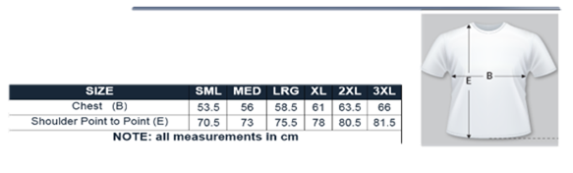

Left blank by design

# Application Form 2020

**NAME:** ………………………………………………………………………………………………… (first and last name)

**DATE of BIRTH:** ……………………….. **Height** ………………………. 􀂈 Male 􀂈 Female

**EXPERIENCE**

|  |  |
| --- | --- |
| 􀂈 I am a previous JDP participant | 􀂈 I have not driven a car before |
| 􀂈 I have driven a manual car | 􀂈 I have competed in a motorsport event before. |
| 􀂈 I have driven an automatic car | 􀂈 I am keen to enter motorsport |

**ADDRESS:** …………………………………………………………………………………..………

…………………………………………………………………………………..………

**EMAIL:** ……………………………………………………

**CONTACT PHONE NUMBER(s):** ………………………………….…………………….

**PARENT / GUARDIAN NAME(s):** …………………………………………….

**Optional 2020 Tarmac JDP Speed Event Shirt $30 Size S M L XL 2XL 3XL**

I …………………………………….…..(parent/guardian) understand it is mandatory for a parent/guardian to be present at every JDP day.

􀂈 **Please contact me to discuss my child’s learning and expectations**

**PARENT / GUARDIAN SIGNATURE:** …………………………………………

**PAYMENT (Full payment of $475 or $100 deposit with registration)**

* All Payments by Electronic Fund Transfer
* BSB 633 000 A/C 1469 18016

􀂈 **Payment in full**

􀂈 **$100 deposit and I will pay the balance of $375 prior to 1st July**

**NOTE:** To withdraw your registration please notify Darren Mattiske (0412 823 171) at the earliest as possible.

To be considered for this and secure your place please return ASAP to:

Scan this and e-mail to secretary@tarmacjdpasa.org.au